**Ideation Phase**

**Define the Problem Statements**

| DATE | 19 September 2022 |
| --- | --- |
| TEAM ID | PNT2022TMID10157 |
| TEAM LEAD | MOHAN RAJU |
| TEAM MEMBERS | KANISHRAM  KALAI SELVAN  KISHORE |
| PROJECT TITLE | SmartFarmer - IoT Enabled Smart Farming Application |

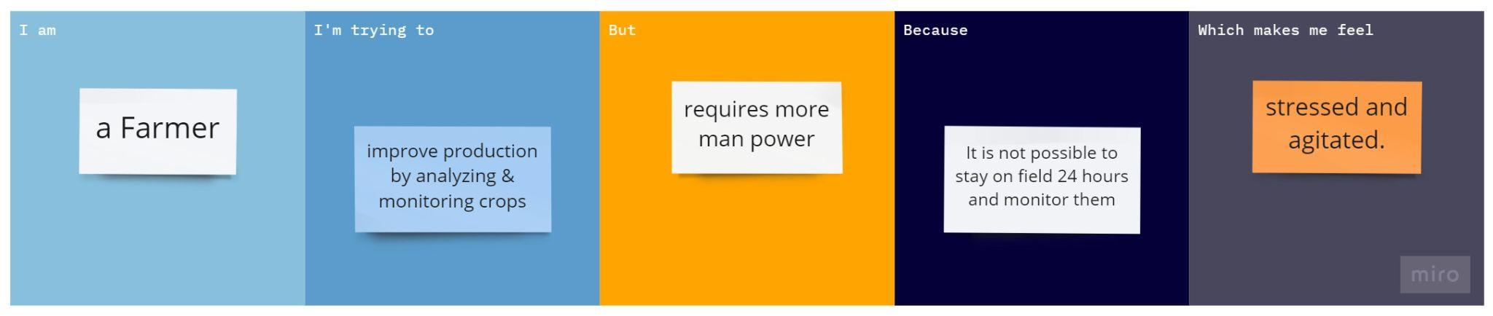

| **Problem Statement (PS):** | An intelligent crop protection system helps the farmers in protecting the crop from the animals and birds which destroy the crop. This system also helps farmers to monitor the soil moisture levels in the field and also the temperature and humidity values near the field. The motors and sprinklers in the field can be controlled using the mobile application. |
| --- | --- |
| **I am** | A Farmer |
| **I’m trying to** | frequently monitor the crops and make sure to prevent them from getting destroyed. Analyze data from various sensors. |
| **But** | requires a lot of man power for surveillance and monitoring. |
| **Because** | It's really hard to cover large boundaries and monitor them 24 hours a day. |
| **Which makes me feel** | Frustrated and fearful about the crops getting destroyed frequently. |